Vocab for Chapter 2 - The Ancient World

****PLEASE PUT YOUR NAME BY YOUR TERM - IF YOU WANT CREDIT !!

1. Apron- **Debbi Wright**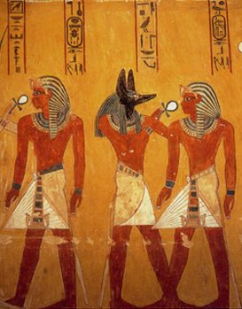

The picture above does show the schenti, but it also shows the apron on two of the persons in the picture. The apron covers the genital area and is worn atop of the other clothing garments underneath. According to our textbook the apron was usually attached to a sash, band or belt. There has been found in Nubia an example of an apron. Nubia was influenced by Egyptian culture. The apron showed the priesthood that was held by the individual.

Citations:

Toratora, Phyllis G, and Keith Eubank. *Survey of Historic Costume, 5th Edition*. Berg, 2009.

[**https://fashionhistory.fitnyc.edu/schenti/**](https://fashionhistory.fitnyc.edu/schenti/)

<https://content.ebscohost.com/ContentServer.asp?T=P&P=AN&K=136080885&S=R&D=hus&EbscoContent=dGJyMNXb4kSep7A4yNfsOLCmsEqep7RSs664SbGWxWXS&ContentCustomer=dGJyMPGuski0p65PuePfgeyx43zx>

1. Animal Hides of Egyptian Priests - Jensen Stenquist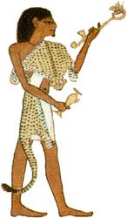

This leopard hide would be worn by an Egyptian priest. The animal hide would typically be fastened across the shoulder. Wearing animal skins was reserved for the most powerful element in society. Later on, the skins were no longer worn, but were replaced by ritual garments made from cloth simulating animal skin. Leopard spots were painted onto the cloth. Egyptians believed that by wearing the skin of a fierce beast the powers of the animal were magically transferred to the wearer.

<https://en.natmus.dk/historical-knowledge/historical-themes/the-fur-trail/fur-in-antiquity/stele-with-an-egyptian-priest-in-leopard-skin/>

<https://www.metmuseum.org/art/collection/search/567608>

Tortora, P. G., & Marcketti, S. B. (2021). *Survey of historic costume*. Fairchild Books.

1. Beaded Dresses- Jessica Fraser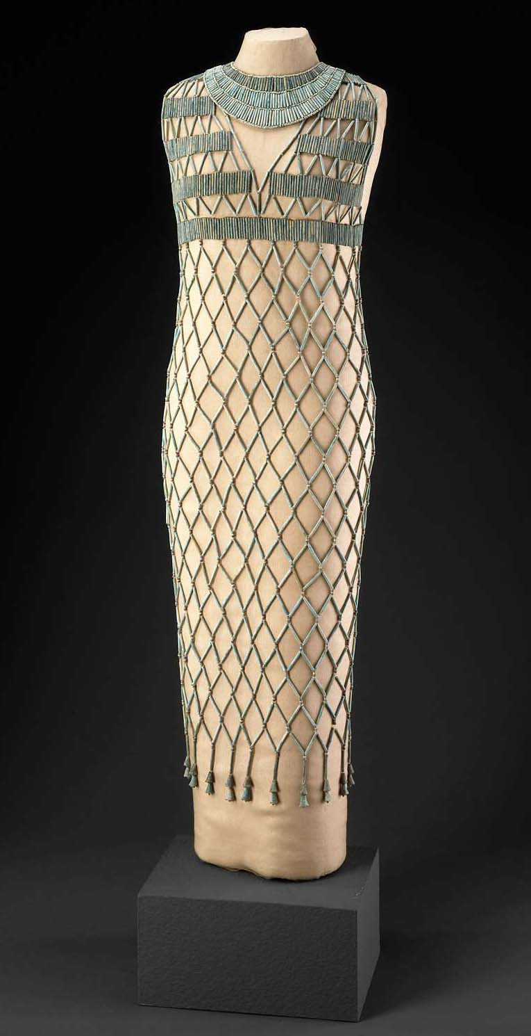

The term I chose was Beaded Dresses. As I looked in the readings it explained that beaded dresses were normally placed over a sheath or wrapped dress. This was done f

or burials as well as normal wear. They have been found in tombs and in other historic areas. They were always but on tight clothes that were hard to put on and wear around. The beads were either sewn to the garment or placed on separately. These were also worn over V-neck dresses to show more of the beaded work that was placed.

Sources:

<https://fashionhistory.fitnyc.edu/beadnet-dress/>

[(Links to an external site.)](https://fashionhistory.fitnyc.edu/beadnet-dress/)

<http://giza.fas.harvard.edu/objects/15308/full/>

[(Links to an external site.)](http://giza.fas.harvard.edu/objects/15308/full/)Survey of Historic Costume

1. Blue or War Crown Ida Johnson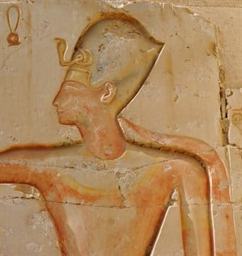

The Khepresh crown was often worn by pharaohs when going into war. During the later 18th Dynasty of the New Kingdom, many pharaohs adopted the Khepresh as their main crown and it can be seen on Tutankhamun. The Khepresh crown had a Uraeus (a standing cobra) in the front symbolizing the power of the Pharaoh against the enemies and his protection by the gods. There are no surviving physical examples, though many believe it was made of leather.

<https://egyptianplanet.com/halloween-costumes-ancient-egyptian-pharaohs-clothing/>

<https://www.ees.ac.uk/the-royal-crowns-of-egypt>

1. Calasiris
2. Chignon - Jalissa Cloward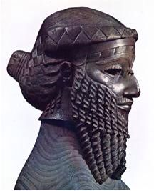

A chignon is a bun that is worn at the nape of the neck. In Mesopotamia, during the Sumerian time period, the chignon was worn by both men and women. It was often braided and was held in place by a fillet, or headband. The king, himself, wore the beard and chignon look.

*Survey of Historic Costume,* pg. 24

<http://www.fashionencyclopedia.com/fashion_costume_culture/The-Ancient-World-Mesopotamia/Mesopotamian-Headwear.html>

<https://www.jeanlouisdavid.us/article/-hair-story-the-chignon-through-the-ages_a12077/1>

1. Falcon or Vulture Headdress- **Ryann Becker**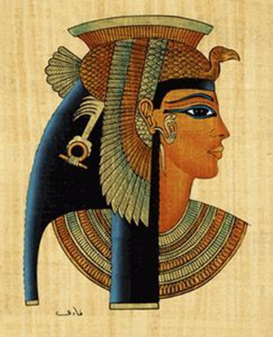

. There were many different kinds of crowns for Egypt royalty, some the Pharaoh wore, and others were worn by their gods. (<https://www.landofpyramids.org/crown-of-egypt.htm>)

This was a type of crown, the Falcon or Vulture headdress, were worn by the queens of Egypt. “The vulture’s wings and body were spread over a tightly fitted cap, and the head jutted out the front” (<https://www.historymuseum.ca/cmc/exhibitions/civil/egypt/egcgov4e.html>) Though a cobra head could be used instead of a vulture head. Both of these were meant to protect the person from harm. The textbook adds additional information, that this headdress is depicted in Egypt art and also in the tombs that have been discovered. This is true for the other clothing, crowns, and jewelry of the time.

1. Fillet- **Aubrey Reidhead**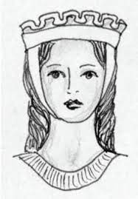

The fillet (fil'it),was a sort of headband that would hold a person’s hair in place. (Textbook) This was commonly worn with a linen band worn under the chin and pinned to the top/sides of the head. Fillets were also fashioned in likeness to a diadem that would be worn like a crown.

<https://fashionhistory.fitnyc.edu/barbette/>

<https://www.metmuseum.org/art/collection/search/246820>

1. Filling Yarns- **Amanda Hair**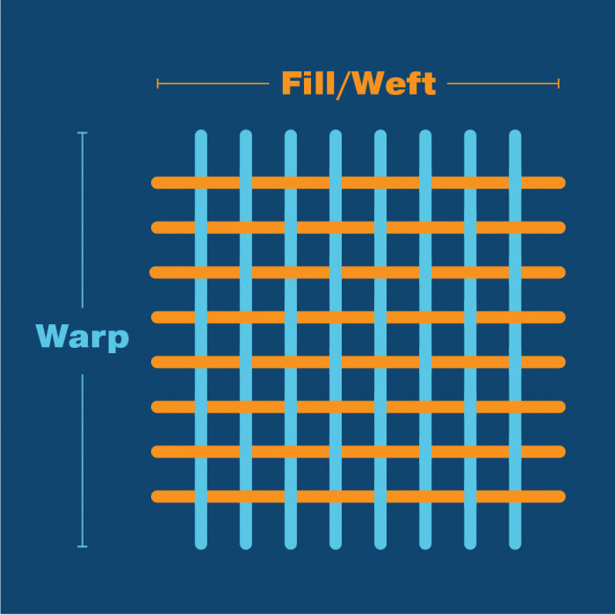

Filling yarns are the substance added to yarn or fabric to fill in open spaces or increase weight. In the Old and Middle kingdoms, the “Egyptians used a horizontal ground loom to weave fabrics of varying widths” as explained in Survey of Historic Costume. The cloth they used consisted of lengthwise warp yarns and crosswise weft of filling yarns. These yarns are made with less twist than warp yarns because they are less strained in the weaving process.

Survey of Historic Costume; Page 32

<https://www.britannica.com/technology/filling-weaving>

https://acadiantextiles.com/news/warp-fill/

1. Flax- **Bailey Pinder**

Flax is one of the oldest cultivated crops in the world. The earliest evidence of humans using wild flax as a textile comes from the present day Republic of Georgia, where spun, dyed, and knotted wild flax fibers were found in Dzudzuana Cave and dated to the Upper Paleolithic, 30,000 years ago. Flax was first domesticated in the Fertile Crescent region. In ancient Mesopotamia, flax was domesticated and linen was first produced. It is a blue flowering plant. Flax is the plant that linen is made out of. Linen fiber is removed from the stems of the flax plant. Flax fibers are taken from the stem of the plant and are two to three times as strong as those of cotton. Flax was raised on large estates owned by wealthy Egyptians. Men would process the flax stems and remove the line fibers, women would spin the fibers into yarns and then weave those yarns into cloth, and then men would do the final cleaning of the cloth where they would either boil it or wash it in the river.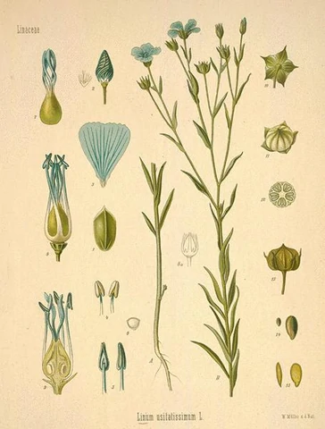

<https://www.agmrc.org/commodities-products/grains-oilseeds/flax-profile>

Survey of Historic Costume, pg 32-33

<https://wholesomelinen.com/pages/linen-flax-history>

1. Henna- **Emma Lewis**
2. Kaunakes - **Alex Clark**

The term that I decided to learn about was kaunakes. The kaunake was a skirt that was made from sheepskin with the fleece still attached to the skin and was one of the earliest known forms of clothing. The kaunake was also one of the first known forms of fake fur. It was worn by everyone but people in roles to that of servants and soldiers wore ones at shorter lengths while royalty and people of higher status wore longer kaunakes. Later on when the sheepskin was changed, people added a fringe to the hem of the dress to simulate the original. 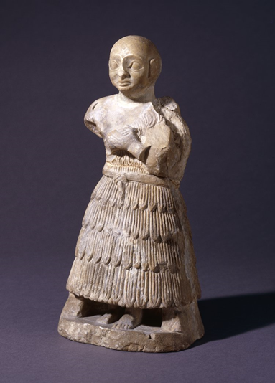

Sources:

Survey of Historic Costume; Page 24

<https://fashionhistory.fitnyc.edu/kaunakes/>

https://en.wikipedia.org/wiki/Kaunakes

1. Kilt- Hailey Child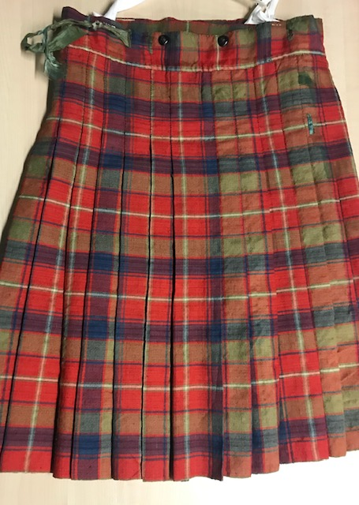

A kilt is a shorter, knee-length skirt worn specifically by Scotsmen. It is in the wrapped skirt category and is worn by men. If a woman were to wear practically the same thing it would be classified as a skirt. Found in the Scottish Highlands, the kilt is a pleated garment typically made up of woolen cloth in a tartan (cross checked repeating pattern).

<https://www.lochcarron.co.uk/blog/the-history-of-the-kilt/>

<https://www.scotclans.com/not-brief-history-kilt/>

Survey of Historic Costume

The kilt was worn to show national identity and patriotism. The tartan pattern of the skirt showed their culture and clan. It was a way to show off your heritage and pay tribute.

1. King Tutankhamon- Lauren Shumway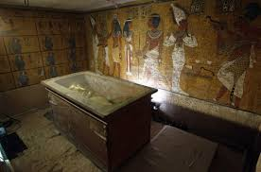

King Tut, as he is commonly known, was a mostly intact tomb in the 1920s leading to the discovery of a large amount of clothing that showed garments of many colors and patterns. This also included examples of bead work, shoes, socks and gloves. Giving Us a better understanding of what the ancient egyptian wore.

Sources

Survey of historic costume; page 31

<https://www.theguardian.com/science/2000/aug/10/technology1>

<https://www.ranker.com/list/king-tut-garments-recreation/shonna-wright>

1. Kohl - **Irelynd Preece**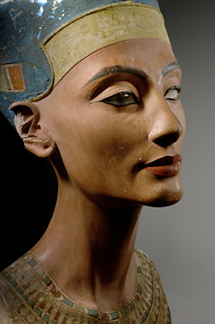

The vocab term that I picked is Kohl. This is eye paint that has cosmetic, symbolic, and medicinal functions. There were different colors, including green and black. It was made of galena which is a sulfide of lead. It is a dark powder that is used as eye makeup worn by both women and men. Some examples of the reasons they wore Kohl was for enhancing the eyes and protection from the sun. When they applied it they would draw even lines above and below the eyes, slightly arching the ends.

Sources: book

<https://www.vocabulary.com/dictionary/kohl>

<https://fashionhistory.fitnyc.edu/kohl/>

1. Linen- **Marisol Dejesus**

Linen is one of the oldest and strongest fibers used for cloth. They symbolize purity, light, and wealth. The fibers came from a plant called flax, which is removed from the stems. Linen is soft, smooth, and cool to touch. They are best for hot climates and when it gets wet the linen becomes even more stronger, which helps the fibers to decay slower.

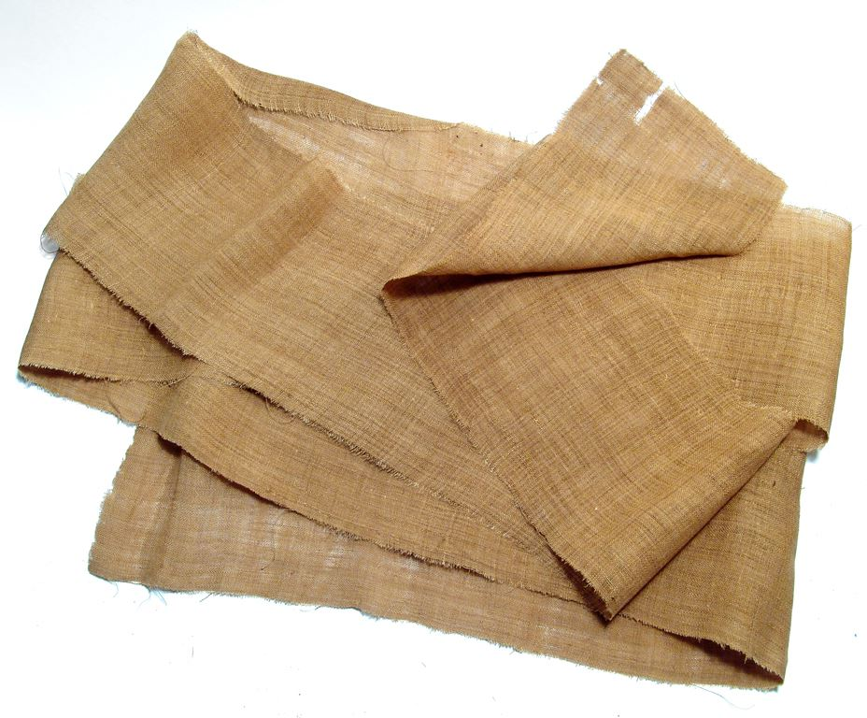

Sources:

Textile Production and Technology; pg.33

<https://handwovenmagazine.com/linen-egypt-and-mummies/>

<http://www.historyofclothing.com/textile-history/history-of-linen/>

1. Lock of Horus - **Abby Fluckiger**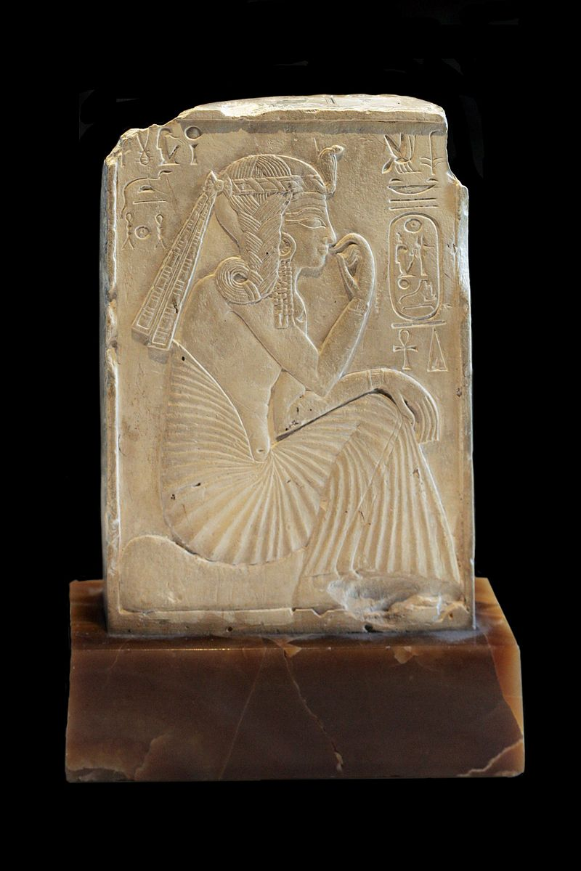

The lock of Horus (also known as the sidelock or lock of youth, prince’s lock, or side braid) was a hairstyle worn only by children of the pharaoh, characterised by a mostly shaved head with one lock on the left side of the head which was braided over the ear (Tortora and Eubank 45). While children of the upper classes also sometimes had a similar hairstyle with unshaven parts of the head, only the specific hairstyle worn by royal children was an actual Horus lock.

There are few online sources discussing the symbolic purpose of the Horus lock, but some suggest that one purpose was to signify that the wearer was a “legitimate heir of Osiris”, the king of the gods, explaining why only royal children could wear it ([Sidelock of Youth](https://en.wikipedia.org/w/index.php?title=Sidelock_of_youth&oldid=968909655)).

Ramses II as a child, depicted wearing a lock of Horus

Sources:

Tortora, Phyllis G, and Keith Eubank. *Survey of Historic Costume*. 5th ed., Fairchild, 2010.

<https://en.wikipedia.org/w/index.php?title=Sidelock_of_youth&oldid=968909655> (Photo credit also to Wikipedia)

<https://exploring-africa.blogspot.com/2010/05/side-lock-of-youth.html>

1. Lock of Youth - **Hannah Ferreira**

The Lock of Youth was a distinct hairstyle that was only worn by the children of the royal family. “The Children of the Pharaoh wore a distinctive hairstyle called the lock of Horus or the lock of youth in which one lock of hair remained on the left side of the head. This lock was arranged carefully in braids over the ear” (42-45). It is commonly mistaken that the hair is lying over their head in straight locks, but it is in fact in braids. This style was worn by both boys and girls until reaching puberty.

Tortora, Phyllis G, and Keith Eubank. *Survey of Historic Costume*. 5th ed., Fairchild, 2010. <http://www.touregypt.net/egypt-info/magazine-mag07012000-mag4.htm>

<https://exploring-africa.blogspot.com/2010/05/side-lock-of-youth.html>

1. Loin Cloth- Claire Moore

Loincloths were an outerwear piece that was often worn by laborers. They are similar to schenti except instead of being just tied on the waist they had a piece of fabric running through the top to tie in the sides. Another main difference is the front was cut into a more triangular shape for the men. The major difference is that these were usually made out of leather, while schenti were normally made out of linen fabric. Loincloths were often worn over whatever linen piece of fabric they wore under. Something that I found interesting is that due to the climate and heat, depending on what the men worked on they would just wear one layer, so either a schenti or a loincloth. 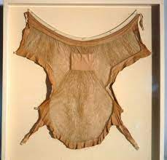

Survey of Historic Costume- page 35

<https://hiyahiyaeurope.wordpress.com/2018/08/09/hiyahiyas-history-of-knitting-the-evolution-of-the-loincloth/>

<https://www.martelnyc.com/ancient-egypt/loincloth-and-loin-skirt.html>

1. Mordants - Kimberly Tesam Moita

A substance that is used to fix colors to fabric when dying. They also help improve how the dye grabs the fibers, and improves the “fastness of a dye. There are many plants which may yield a color that is brilliant and pleasing but fades easily, unless fixed using a mordant.” So it helps the dye stick to fibers that otherwise won’t have vibrant colors or doesn’t dye well. Mordants are usually classified into 3 different categories: metal salts, Tannins and tannic acid, and oils (otherwise known as oil mordants.) The word mordant actually comes from the latin word “mordere” which means “to bite”. Then once they applied the mordant to the fabric and then dyed, the colorfastness of the dye was stronger, and less likely to wash away. Below are some examples of mordants used to fix natural dyes to fibers.

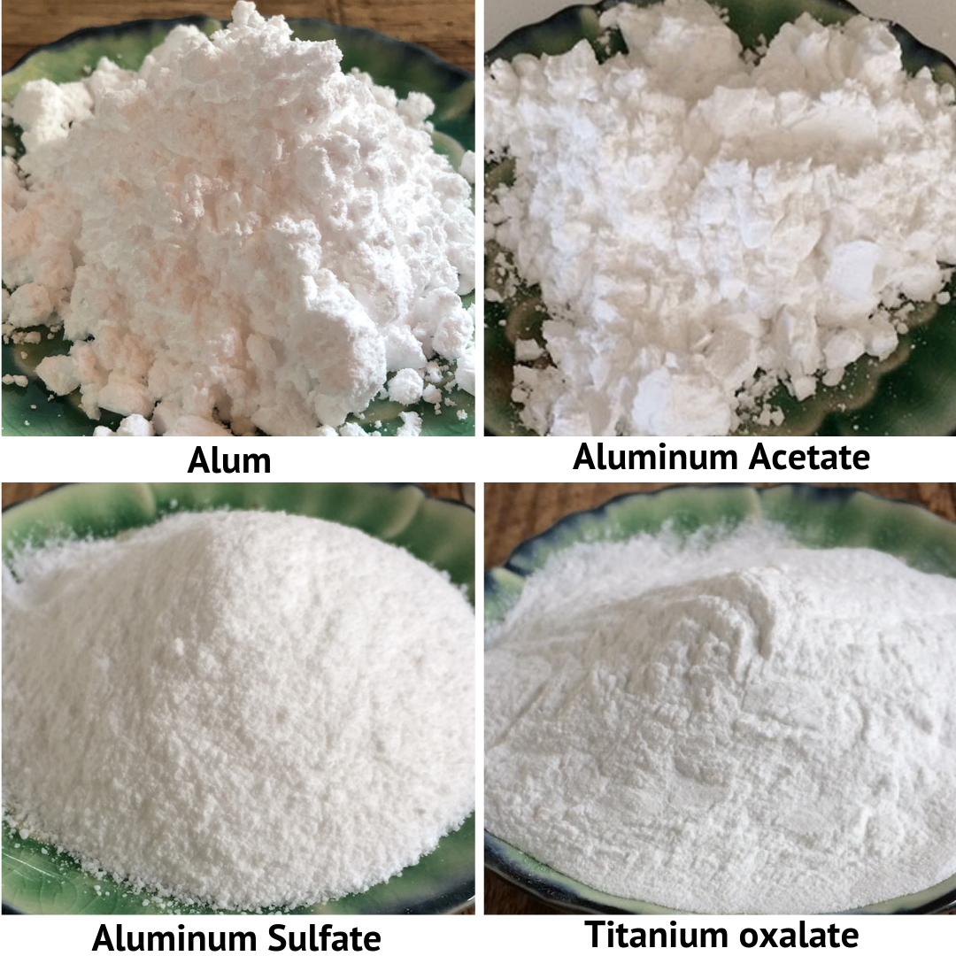

<https://www.sciencedirect.com/topics/chemistry/mordant> , <http://www.wildcolours.co.uk/html/natural_dyes_mordants.html> ,

<https://madderlane.com/natural-dyes-mordants-and-assists-available-at-the-yarn-tree-2/its-all-about-the-mordants-and-assists/>

1. Nemes Headdress-Jamie Rakes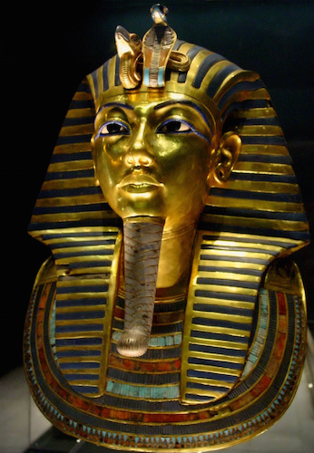

The Nemes headdress was most known for being worn by king tut who is one of the most well known pharaohs. This is because the nemes headdress was worn only by pharaohs. There is a lot of symbolism in the headdress including it’s bright colors and There is a ureaus which is a type of serpent that represent the pharaohs divinity. It was then raised by the shoulders and was stiffer there using a starch and then all brought to the back to into a que like way to simulate the lions tail of sovereignty.

<https://fashionhistory.fitnyc.edu/nemes-headdress/>

Textbook page 24-25

<https://www.martelnyc.com/ancient-egypt/headdresses.html>

1. Nile River- **Savannah Tanner**
   * The Nile river was often referred to as the lifeblood of Egypt and the surrounding countries. It hits approximately 6,600 kilometers in length before merging with the Mediterranean Sea. The Nile River was utilized as a form of irrigation and trade for thousands of years. Egyptians used the Nile to divide their lands into Kemet or “black land” for the Nile Valley, and the desert portions as Deshret or “red land.” The Nile River brought life to them and combatted the harsh desert environments.
   * 
   * <https://www.nationalgeographic.org/encyclopedia/nile-river/>
   * <https://www.history.com/news/ancient-egypt-nile-river>
   * Pgs 20-21
2. Pectorals- Abigail Storrer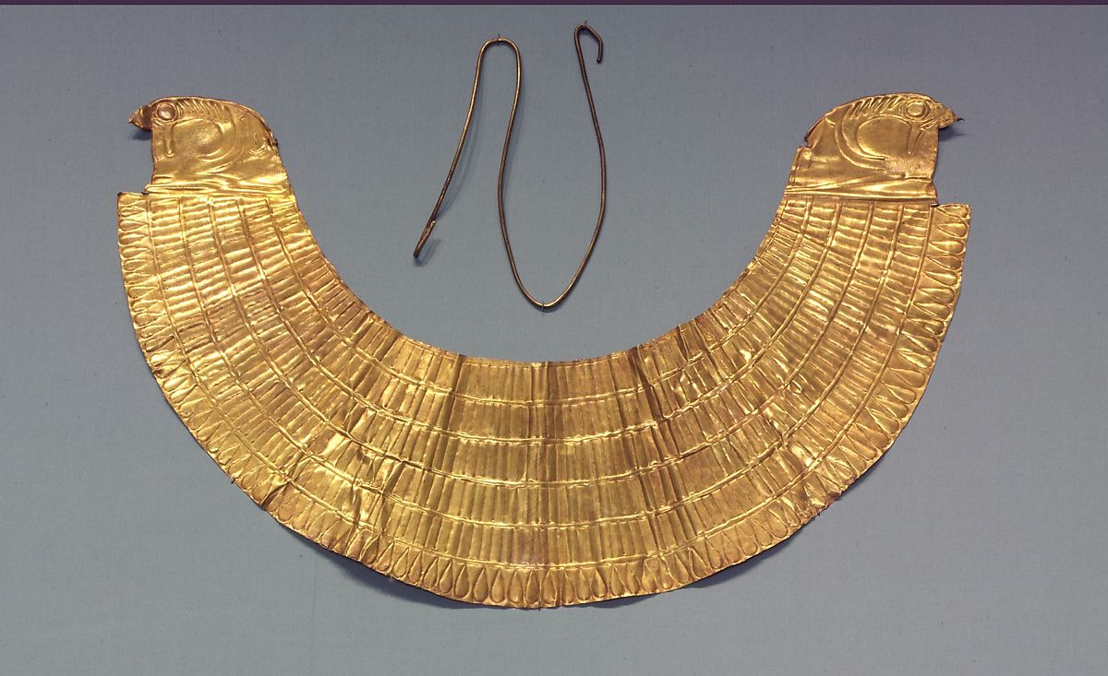

The term that I chose was pectorals. This item was a kind of jewelry worn in Egypt that was like a fancy necklace or breastplate that hung from the neck. It was made of metal and decorated with stones and symbols. The more colorful the pectoral was the more it showed richness and status. These were also thought to be good luck. For royalty and gods there were symbols or hieroglyphics that helped represent them. The materials that they were made out of were usually gold or copper.

Sources:

Tortora, P. G., & Eubank, K. (2010). *Survey of historic costume: A history of western dress*. Fairchild.

<http://www.fashionencyclopedia.com/fashion_costume_culture/The-Ancient-World-Egypt/Collars-and-Pectorals.html>

[https://www.artyfactory.com/egyptian_art/egyptian_hieroglyphs/pecthttps://www.metmuseum.org/art/collection/search/548449oral.html](https://www.artyfactory.com/egyptian_art/egyptian_hieroglyphs/pectoral.html)

<https://www.metmuseum.org/art/collection/search/548449>

1. Pschent Crown- Anna Ament 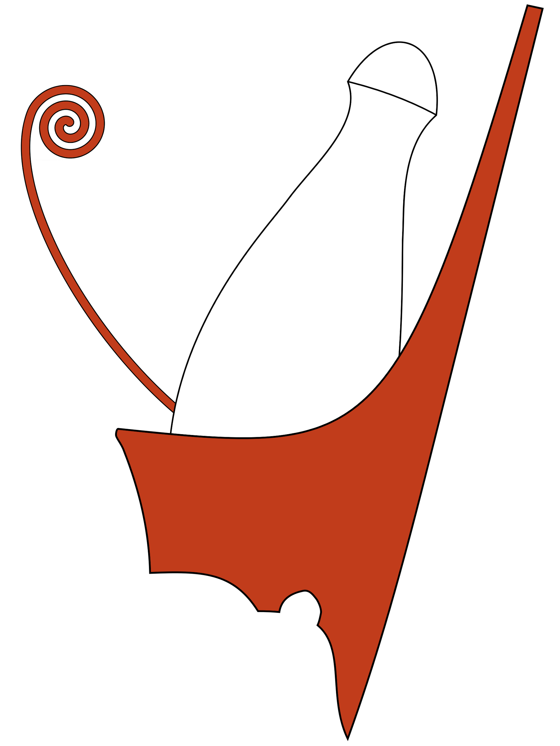

I found it very interesting that there has never been a physical finding of the Pschent Crown. The only information we have of this traditional headpiece is found in artistic interpretations. Yet, historians are able to tell so much about its origin and symbolism. This double crown represents the joining of upper and lower Egypt along with Pharos power over them.

[https://www.thoughtco.com/double-crown-of-egypt-43897 (Links to an external site.)](https://www.thoughtco.com/double-crown-of-egypt-43897)

<https://www.ees.ac.uk/the-royal-crowns-of-egypt>

1. Red Crown of Lower Egypt- Brittany Pocock

The red crown was a symbol of the rule over lower egypt. In mythology Geb the original ruler of egypt wore the red crown also known as Deshret. Other pharaohs who saw themselves as successors of horus would wear them to signify their authority over lower egypt. There were also other deities depicted wearing the Deshret such as the Goddess Wadjet. The Red Crown was later combined with the white crown making the double crown and representing rule over all the land. There has been a physical red crown found which suggests that the crown may have gotten passed from regent to regent.

[VitalSource Bookshelf: Survey of Historic Costume](https://bookshelf.vitalsource.com/reader/books/9781628921687/epubcfi/6/20%5B%3Bvnd.vst.idref%3Dnav_18%5D!/4/644/4)

[Deshret - Wikipedia](https://en.wikipedia.org/wiki/Deshret)

[Crowns of Ancient Egypt | Ancient Egypt Online](https://ancientegyptonline.co.uk/crowns/)

1. Crown of Upper Egypt- **Elizabeth Nathan**  The crown of Upper Egypt was white and cone shaped, while that of Lower Egypt was red and flat, with a rising projection in back and a spiral curl in front.Often these two crowns were combined to form the double crown, symbolizing the unification of Upper and Lower Egypt under the divine king. 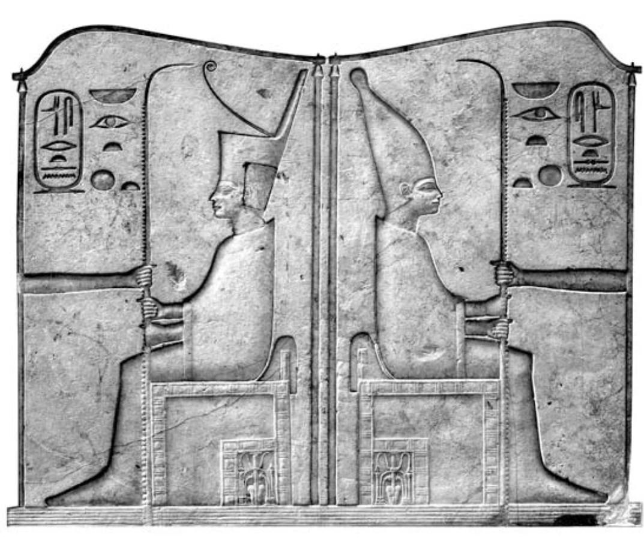

<https://www.britannica.com/topic/crowns-of-Egypt>

<https://www.ees.ac.uk/the-royal-crowns-of-egypt>

1. Seams
2. Schenti (shent, skent, or schent)- **Andrea Lazaro Hernandez**

A schenti was a common piece of clothing worn by male Egyptians. It consisted of a piece of cloth wrapped around the hips and tucked on one end to the waist or sometimes held by a belt. Some schentis were knee length while others would reach to the ankle. Sometimes schentis were decorated with patterns. Different materials were used for the schentis, but the most common one was linen because it was fresh in the hot weather. Even though schentis were worn by men of different social classes, they are normally associated with the upper class. Evidence of schentis can be found in hieroglyphs, where men are represented wearing them.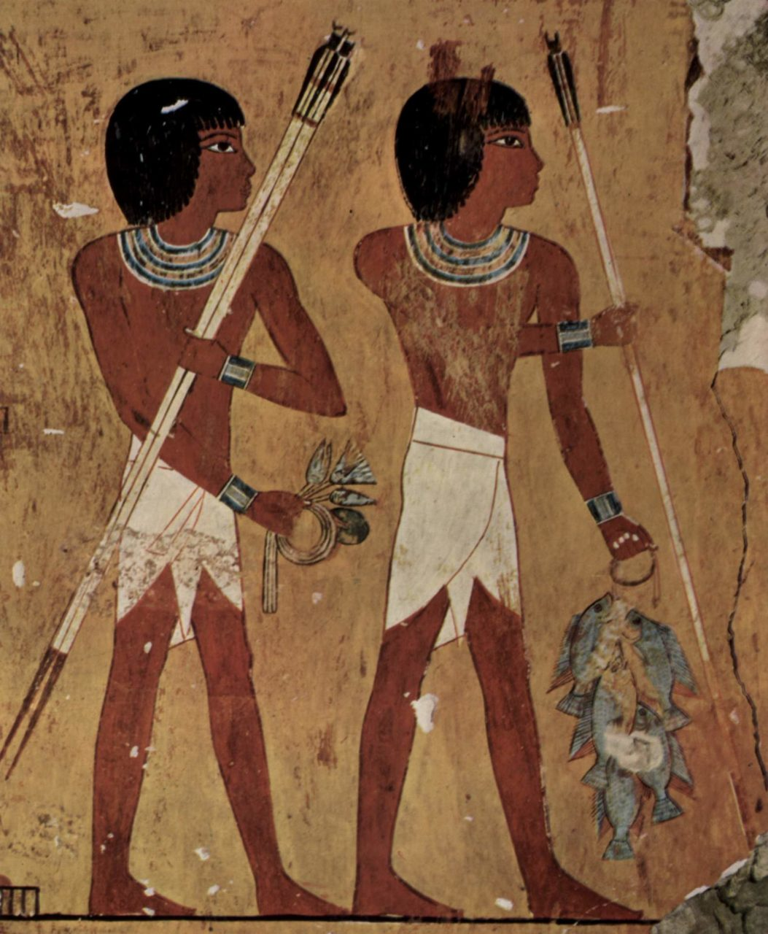

Sources:

Tortora, P. G., & Eubank, K. (2010). *Survey of historic costume: A history of western dress*. Fairchild. Page 36

<https://fashionhistory.fitnyc.edu/schenti/>

<https://www.britannica.com/topic/loincloth#ref204055>

1. Selvage: Lexie Pincock

It is located on the edges (on both sides of the fabric) where the weft yarn turns and winds back across the fabric. It is used to prevent the edges of the fabric from fraying and coming undone. It is a lot sturdier than the rest of the fabric and not really used when creating a garment. 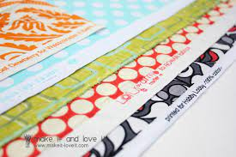

SOURCES:

Pg. 33

<https://www.allpeoplequilt.com/how-to-quilt/quilting-basics/what-selvage>

​​<https://www.merriam-webster.com/dictionary/selvage>

1. Shawls and Cloaks
2. Sheath Dress- Samantha Hooper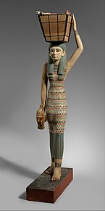

Sheath dresses are one of the most common styles worn by women in ancient Egypt. The style crosses socioeconomic bounds. Sheath dresses often appear as tubes that were fitted to the body. While these dresses are often seen in Egyptian art, none of them have been found in excavations, and historians are not sure that these dresses would have been realistically wearable in this era. They would have been difficult to put on and to move around in with the fabrics of the time.

Pg 38

<https://startupfashion.com/fashion-archives-history-sheath-dress/>

https://en.wikipedia.org/wiki/Clothing_in_ancient_Egypt

1. Straps
2. Tunic - **Abbie Burns** 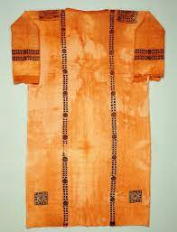

Lower class men and women often wore V-neck tunics, a loosely fitted garment; pg:41 (the book) The tunic consisted of a long rectangular garment with one hole cut out for the head. The two open sides of the garment were secured with a belt, and often paired with schenti. This article of clothing was made with linen fabric. I found it interesting that although the v-neck tunic was found on lower class citizens the tunic itself was worn by upper class society. Over time the tunic became more advanced with the sides being sewn and the shoulder would form short sleeves and would become starched; making them stick out for the appearance of broad shoulders.

Sources

Book:pg 41

<http://www.fashionencyclopedia.com/fashion_costume_culture/The-Ancient-World-Egypt/Tunic.html#:~:text=An%20Egyptian%20man%20wearing%20a,usually%20worn%20with%20a%20schenti> <https://www.albanyinstitute.org/details/items/ancient-egyptian-tunic.html>

1. Uraeus - Marisa Bone

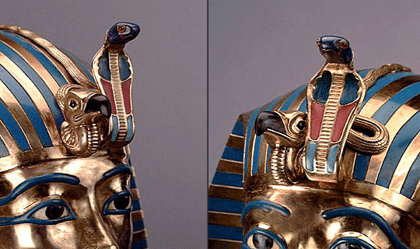

The Uraeus is worn by kings and queens and other superior members of royalty. It is a representation of a cobra which was a symbol of royal power and the Goddess Wadjet ands name is translated into “the chosen one.” It also symbolized the connection between the royalty and the Gods. It could be worn on a headband or as part of another headdress.

Sources

* Survey of Historic Costume, page 44
* [Met Museum](https://www.metmuseum.org/art/collection/search/546039)
* [Ancientsymbols.com](https://www.ancient-symbols.com/symbols-directory/uraeus.html)

1. Veils - Jocelyn Munoz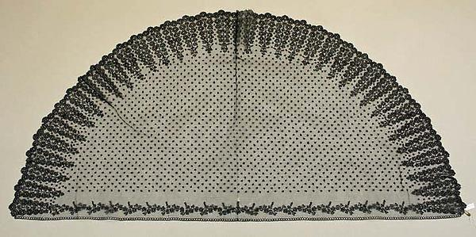

(This is a veil from the late 1800's)

Veils were most likely first worn in the Assyrian empire and were one of the first garments to be enforced by law. They were only allowed to be worn by “free, married women”. (pg. 29) While the veils have been depicted as mostly being worn on the side of the face, covering their hair, apparently, they were mostly worn covering the face, in public at least.

Tortora, P. G., & Marcketti, S. B. (2021). two. In *Survey of historic costume* (pp. 29–29). essay, Fairchild Books.

<http://www.fashionencyclopedia.com/fashion_costume_culture/The-Ancient-World-Mesopotamia/Veils.html>

<https://vintagefashionguild.org/hat-resource/veil/>

<https://www.metmuseum.org/art/collection/search/98284>

1. Warp Yarns
2. Weft Yarns - Claire Lynes

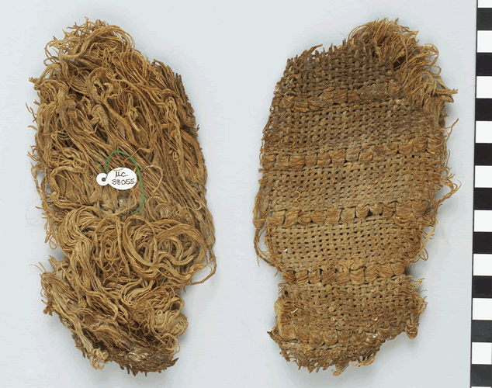

Like us in the modern day, ancient Egyptians used a loom to weave their fabric. On a loom there are two directions that the yarns are placed. The weft yarns move side to side, weaving through the warp yarns (Online Clothing Study). On the sides of the fabric there is the selvage, which is where the weft yarns are returned through the warp yarns (Survey of Historic Costume, 32). The weft yarns have more give than the warp threads and the design in a fabric is normally made with the weft threads (Fibers and Design).

Sources:

Tortora, P. G., & Marcketti, S. B. (2021). two. In *Survey of historic costume* (pp. 32-33). essay, Fairchild Books.

​​<https://www.onlineclothingstudy.com/2020/02/warp-and-weft-meaning-in-fabric.html>

<https://fibersanddesign.com/differencebetweenweftandwarpyarns/>

1. Wool -Savannah Jeppson

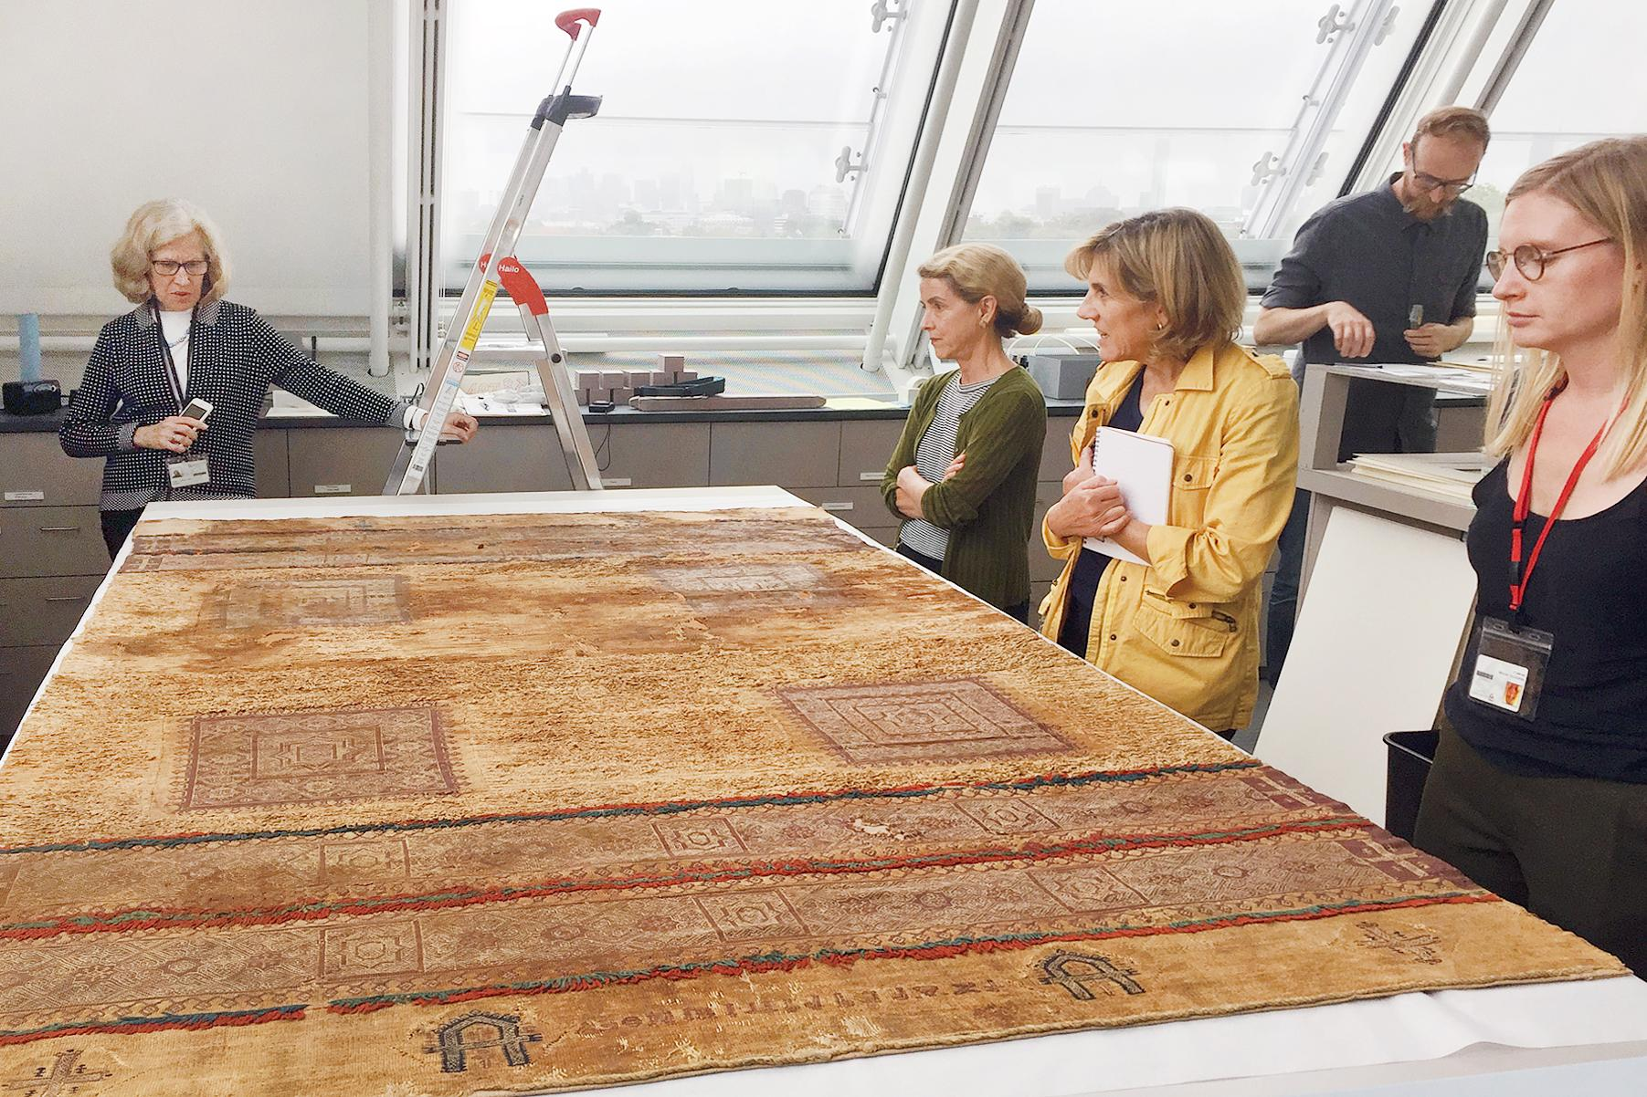

While linen was the main fiber used in Ancient Egypt, wool was still used (Inside Egypt), but “considered ritually ‘unclean’ and was not worn by priests or by visitors to sanctuaries, or for burial” (Survey of Historic Costume, 32). Due to their beliefs, the wool was not allowed to touch their skin because it came from an animal (History Link).

Tortora, P. G., & Marcketti, S. B. (2021). two. In *Survey of historic costume* (pp. 29–29). essay, Fairchild Books.

<https://historylink101.com/n/egypt_1/a-clothing.htm>

<https://www.inside-egypt.com/the-fashions-and-fabrics-of-ancient-egyptians.html>

<https://harvardartmuseums.org/article/unraveling-the-production-secrets-of-an-egyptian-textile>

1. Where & what is Babylonia: Madison Frost

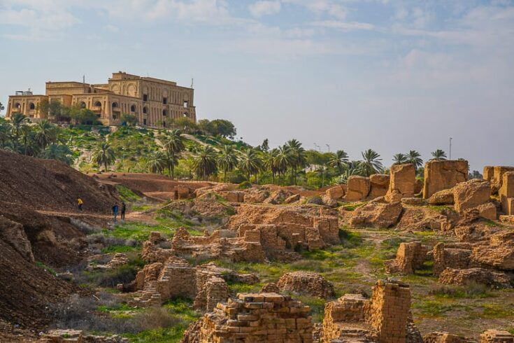

Babylonia was a state in ancient Mesopotamia. The ruins are located in modern-day Iraq and this city was founded over 4,000 years ago. It became a very large and successful military city under the rule of Hummerabi. This empire ended very quickly after Hummerabi’s death. Cyrus the great would eventually conquer Babylon. However, Babylon was considered to be catner of commerce, art and learning.

<https://www.history.com/topics/ancient-middle-east/babylonia>

<https://en.wikipedia.org/wiki/Babylon>

Tortora, P. G., & Marcketti, S. B. (2021). two. In *Survey of historic costume* (pp. 29–29). essay, Fairchild Books.

1. Where & what is Sumeria: Kya Boyd

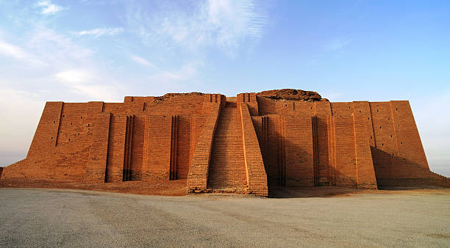

Sumer is an ancient civilization in the Mesopotamia region settling between the Tigris and Euphrates rivers around 4000 B.C. Sumerians were people who developed sophisticated agriculture, religion and political systems. Sumerians are known as the creators of civilization as they maintained control for 2,000 years. Sumerian civilization thrived as well as Egypt by farming and raising cattle, weaving textiles and indulging in carpentry and pottery.

Sources

<http://www.differencebetween.net/miscellaneous/difference-between-sumerians-and-egyptians/>

<https://www.history.com/topics/ancient-middle-east/sumer>

<https://www.istockphoto.com/photos/sumerian-civilization>